Email Integration with Jenkins and Plugin Setup
Step-1:
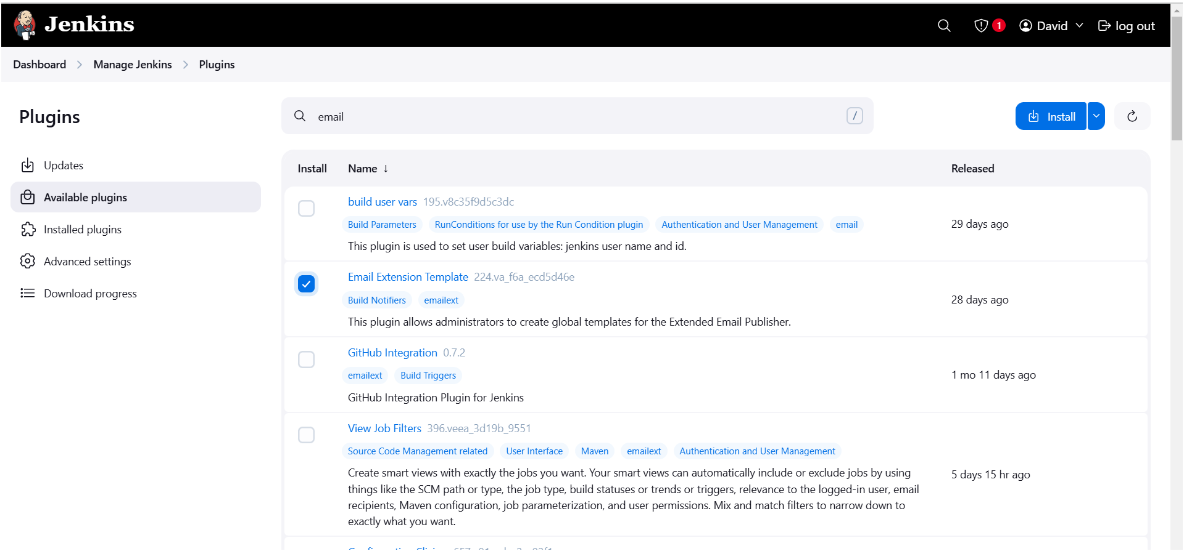

Step-2:
- Go to your Gmail and click on your profile
- Then click on Manage Your Google Account –> click on the security tab on the left side panel you will get this page (provide mail password).
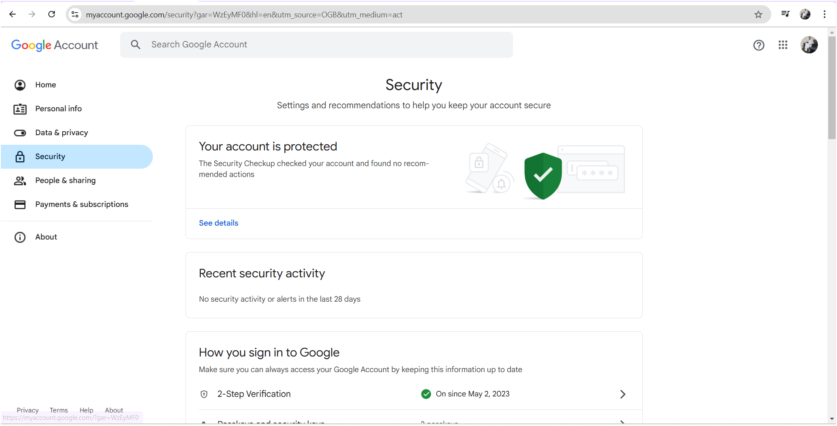
- On search bar type app you will see app password
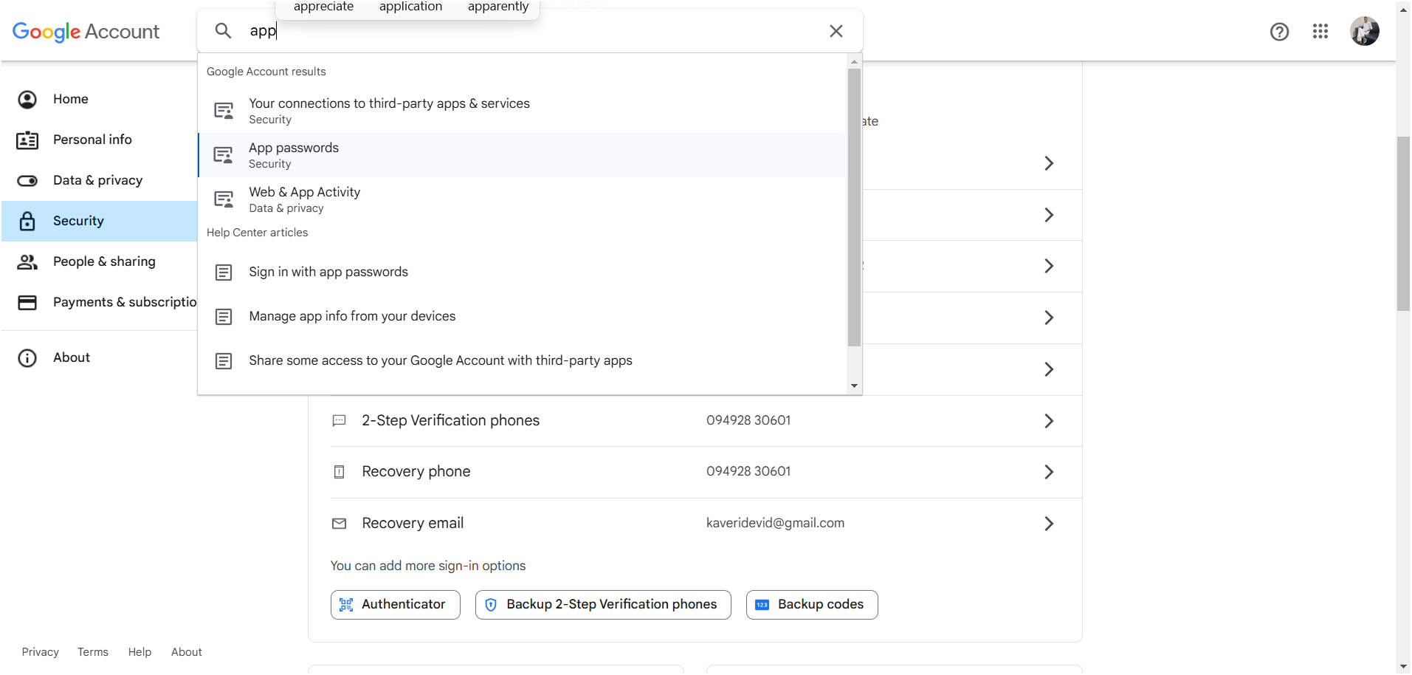

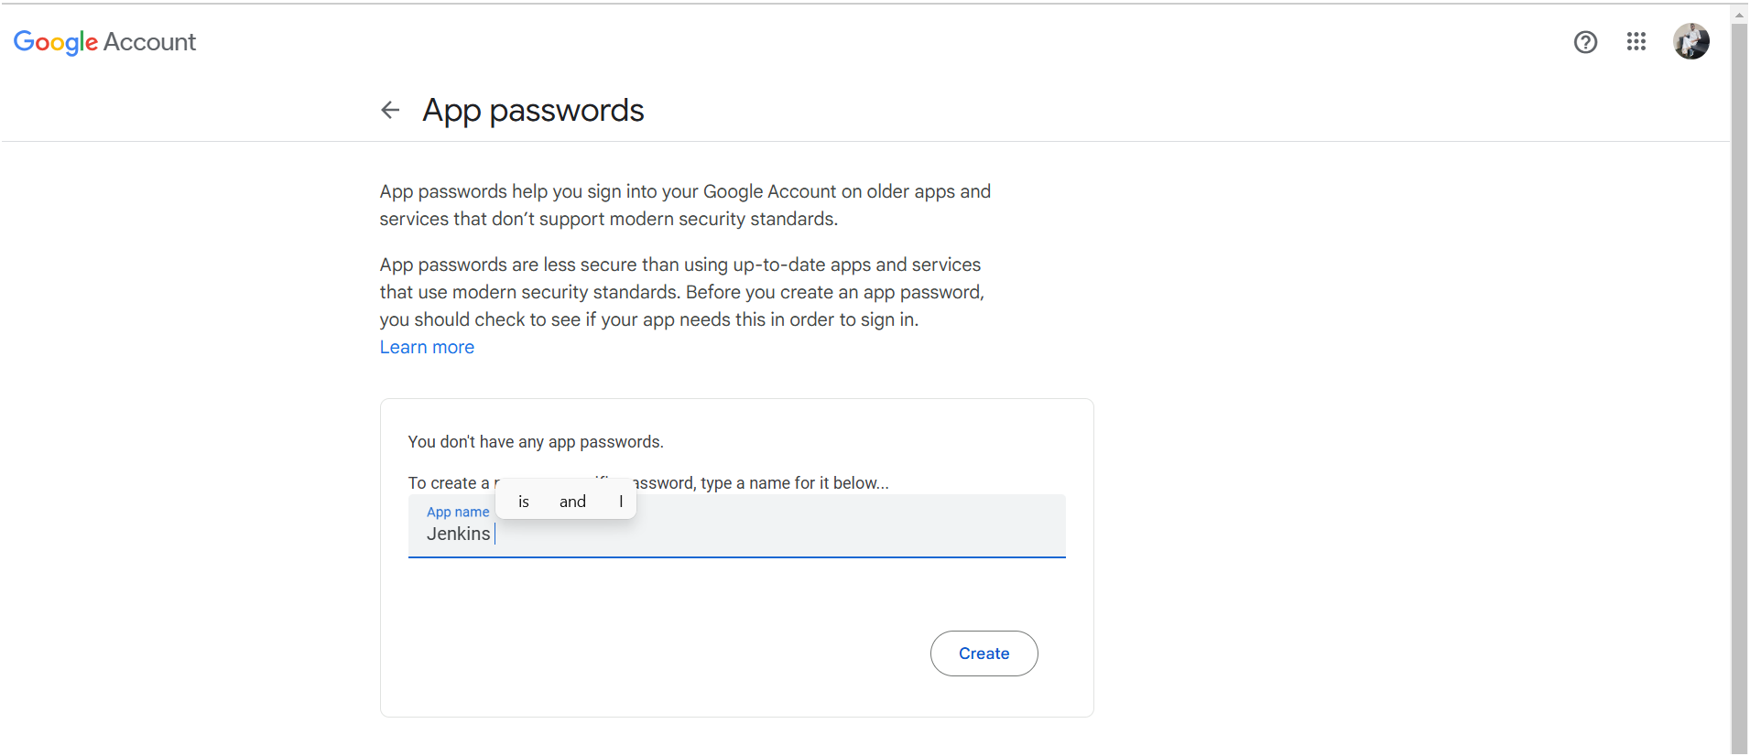

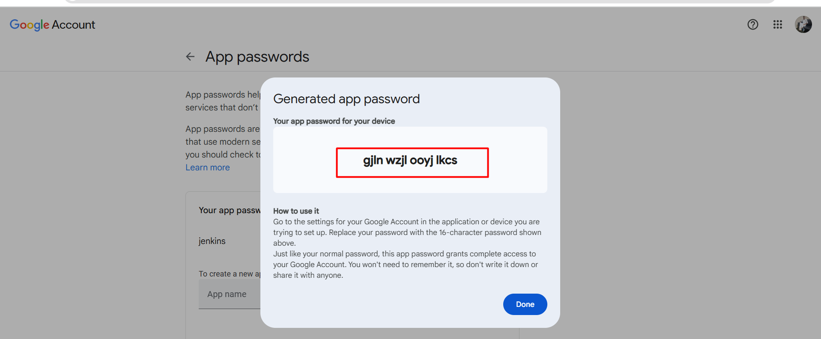
- Copy n save the passwd

Once the plugin is installed in Jenkins, click on manage Jenkins –> configure system there under the E-mail Notification section configure the details as shown in the below image
- Configure as below highlighted
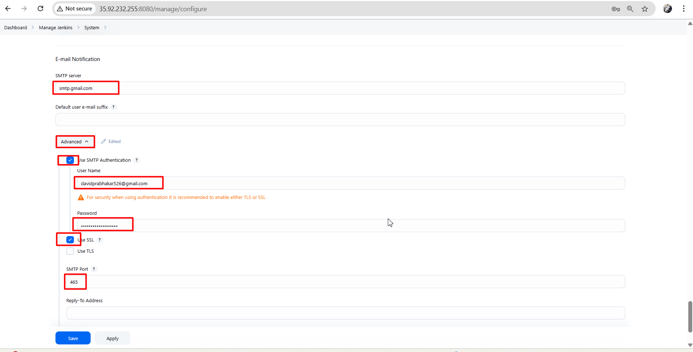

- Provide ur gmail for testing purpose
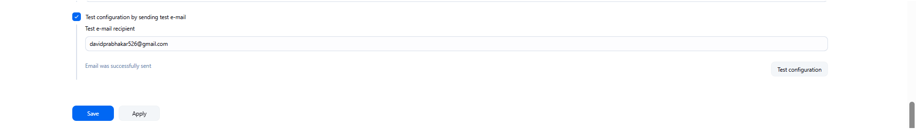

- After check ur mail it will send on test mail
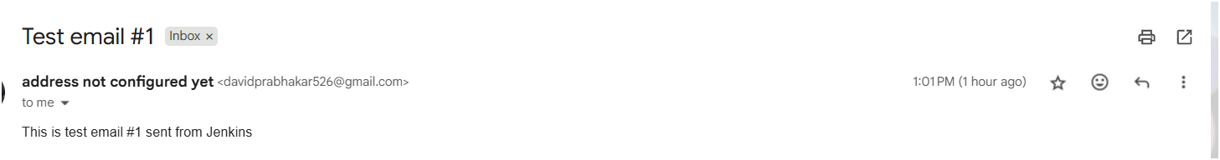
- After click on apply and save
- Click on Manage Jenkins–> credentials and add your mail username and generated password
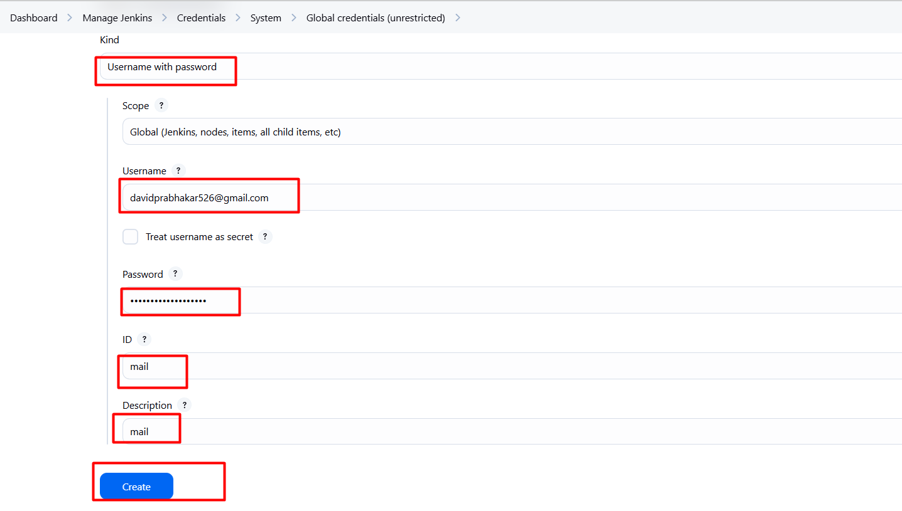
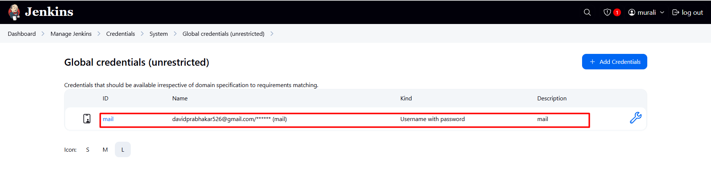
Now under the Extended E-mail Notification section configure the details as shown in the below images
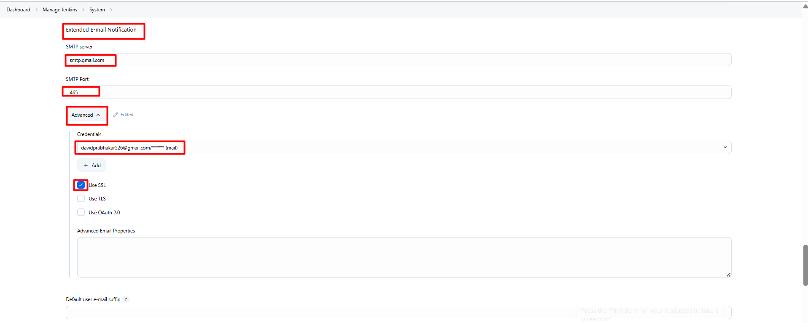
- Next follow steps
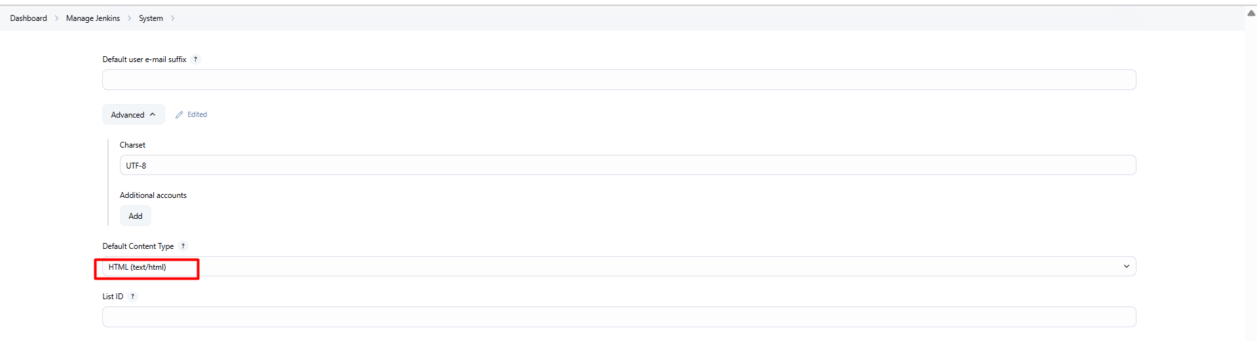
- Next click on additional groovy classpath > default triggers
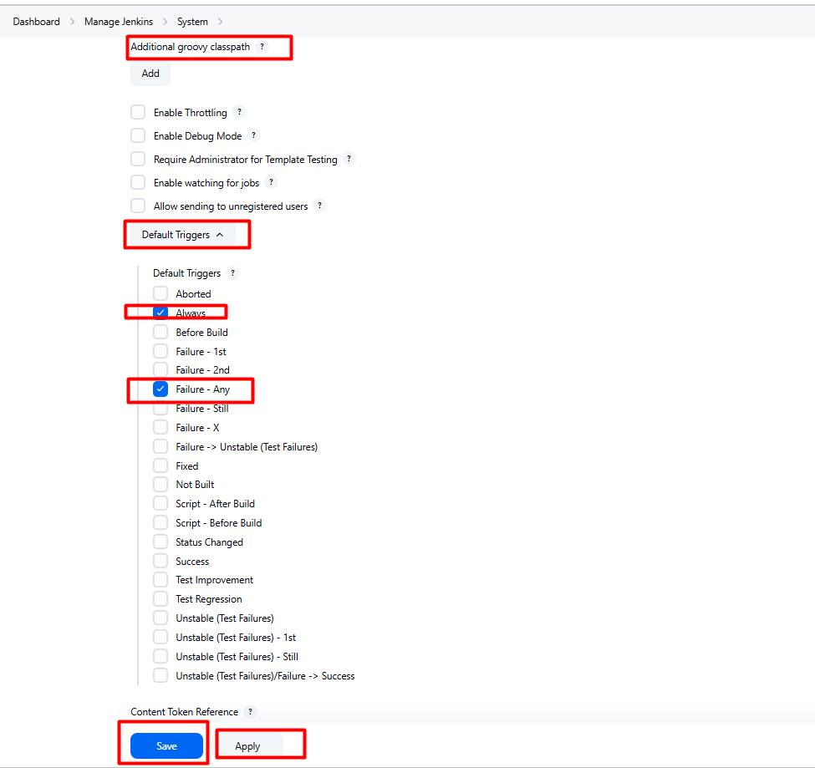
- After click on apply n save ️

SonarQube – Jenkins pipeline script
pipeline {
agent any

environment {
SCANNER_HOME = tool 'sonar-scanner'
}

stages {
stage('Checkout') {
steps {
git branch: 'main', credentialsId: 'githubt-token', url: 'https://github.com/Davidgit526/Admin-Retail-Application.git'
}
}
stage('SonarQube Analysis') {
steps {
withSonarQubeEnv("sonar") {
sh """
${SCANNER_HOME}/bin/sonar-scanner \\
-Dsonar.projectKey=Retail-app-code-quality \\
-Dsonar.projectName=Retail-app-code-quality
"""
}
}
}

}

post {
success {
emailext (
subject: "SUCCESS: SonarQube Quality Gate Passed",
body: """
Hi Team,

The SonarQube quality gate passed successfully.

You can view the report here:
http://44.227.100.103:9000/dashboard?id=Clahan-app-code-quality
username: admin, passwd: pass

If you want to download a PDF report, please use the SonarQube interface or a PDF plugin.

Regards,
Jenkins
""",
to: 'muraliclahan526@gmail.com'
)
}
failure {
emailext (
subject: "FAILED: SonarQube Quality Gate",
body: """
Hi Team,

The SonarQube quality gate has failed.

Please check the details:
http://44.227.100.103:9000/dashboard?id=Clahan-app-code-quality
username: admin, passwd: pass

Regards,
Jenkins
""",
to: 'muraliclahan526@gmail.com'
)
}
}
}

